**Authors:** Jaden Jefferson

**Last Updated:** 6 Mar 2025

How to Read Serial Data on a Cisco 2960-X Switch using Windows 11

## Objective

* Read Cisco serial data transmitted over console port
* Begin initial configurations through Cisco CLI
* Ping switch from PC
* Ping PC from switch

**Note:** If your device has already been set up and you would like to read serial data from your device, please read Getting Port Driver and PuTTY and Step 6 of First Time Setup

## Getting Port Driver and PuTTY

Serial data will be transmitted from the switch to your PC using the switch’s console port and your PC’s USB port. However, your system may not be able to read this data this coming on with pre-existing drivers on your system. For this, please **download the Cisco port driver** at [Software Download - Cisco Systems.](https://software.cisco.com/download/home/282774228/type/282855122/release/3.1) For this you will need to create a Cisco account profile and download the the zip file. For more information on this process, please follow the attached README file. **For PuTTY**, here is an available [download](https://www.putty.org/).

## First Time Setup

**Note:** This is only needed if using a brand new switch or one that has been wiped.

Before diving head first into setup it is essential that you know more about your device and have a good foundational knowledge of it. If you haven’t already, read 1-19 of [Catalyst 2960-X Switch Hardware Installation Guide.](https://www.cisco.com/c/en/us/td/docs/switches/lan/catalyst2960x/hardware/installation/guide/b_c2960x_hig.pdf)

Below we will complete steps 1-6 in [Getting Started Guide](https://www.cisco.com/c/en/us/td/docs/switches/lan/catalyst2960xr/hardware/quick/guide/b_gsg_2960xr.html#:~:text=This%20guide%20provides%20instructions%20on%20how%20to%20use,port%20and%20module%20connection%20procedures%2C%20and%20troubleshooting%20help.). You are encouraged to read through the site if also configuring the physical hardware components for the first time outside of wiring. This is needed to verify all needed materials are owned.

The provided Cisco document is outdated so please read carefully. We will use multiple documents for this configuration pointing to the exact sections needed for each.

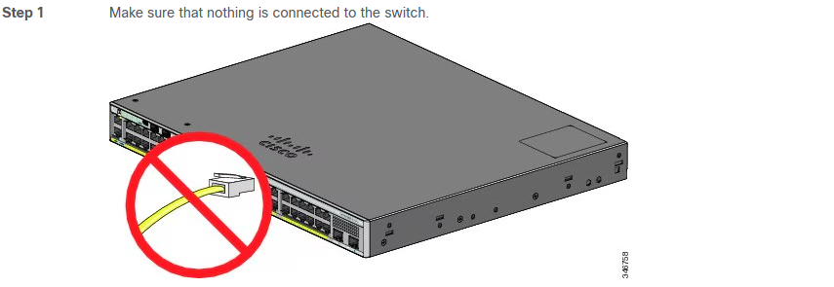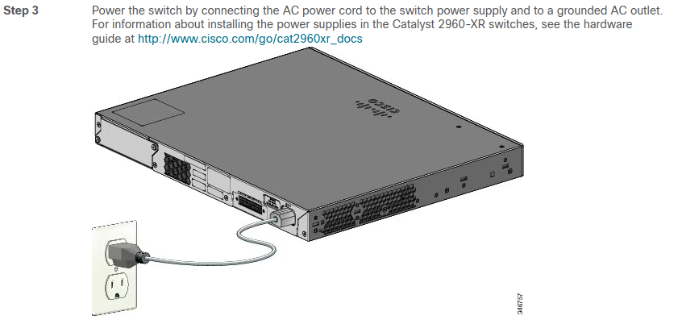

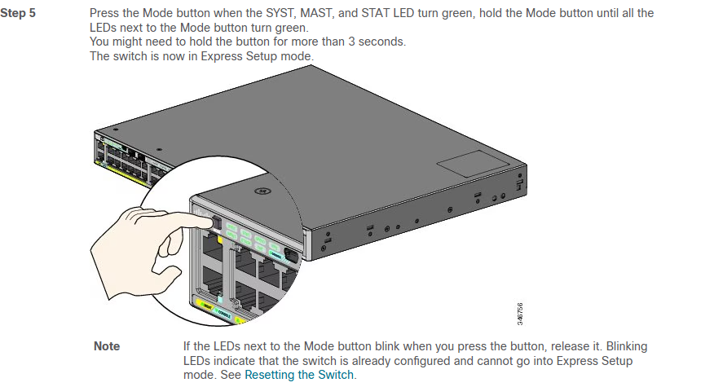**Step 6**

Now that you have completed steps 1-5, we should now be able to read serial data via the console port.

1. Using the micro-B console port, plug the USB micro-B port into the switch and the USB-A port into your laptop.
   1. You will also be able to use any console port rj-45 or micro-b to USB-B for serial data to be transmitted to your pc.
2. Open Device Manager

Check the COM port of your new plugged in device

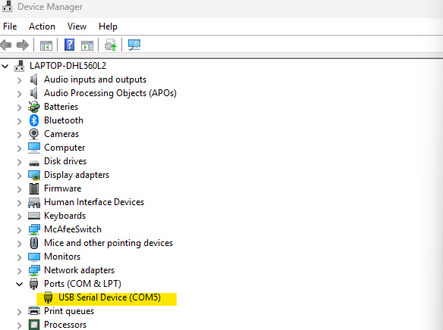

1. Open Putty

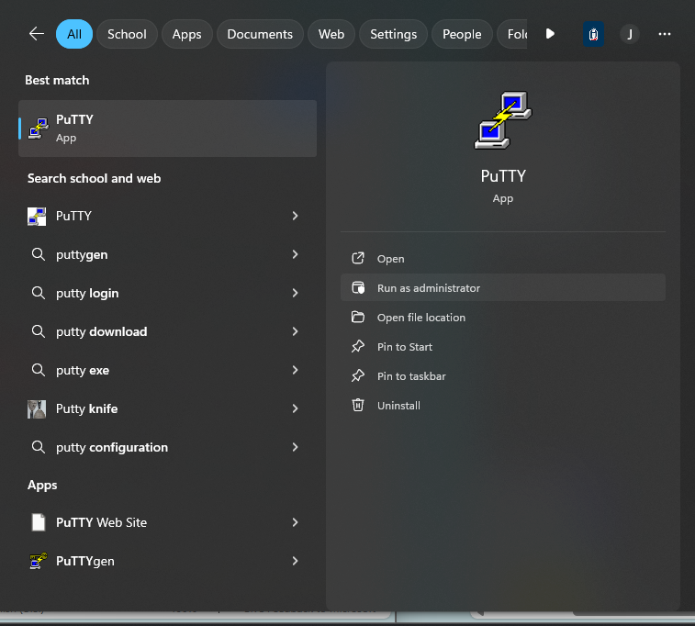

1. Insert the Serial COM Port seen in Device Manager, select serial speed 9600, Connect type Serial and Telnet, Then click *Open*

